**Evolution document**

During the course of project development, and while we were developing the Mapped Race, we ran into several problems we had not considered since the very beginning in our planning stage.

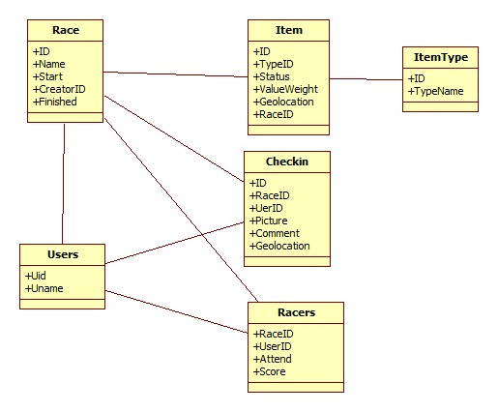One of the main, and biggest changes developed, was modifying the current database class architecture we had planned, and change it in order to meet the requirements and problem issues we were confronting at the time. For example, in the Race table, we had before two values called startDate and startTime. While coding, we found out both values could be joined together, and retrieve either the date or the time from the same slot without any problem. Another main issue we confronted was the Users table, since in the beginning we had only a userID and a username, but we depended heavily in the Twitter authorization process, and how they handle these. When one of our teammates worked on this feature, he found out Twitter was sending a lot of information, and we proceeded to add that info into our database. Days later, and after joining that feature into the system, we discovered, this attributed were not required for the project, and proceeded to delete them, and came back to our original proposal.

In the UI two minor changes were performed. The first is present in the Create Race page, where at the beginning the user set the final destination written. We consider this was not a feasible solution, so we proceeded to deleting this text box, and allowing the user to add a final destination through a button that enables adding one, and by clicking on the map, a pin was dropped. This feature was also added to positive and negative items. The second change is present in the Check-in page. Since this project is a web application, we do not have access to the main functionalities of the smartphone, so we had added a button that later will pop-up a text box to add a URL to an image somewhere in the web. Instead of doing it a two step process, we added directly the text box to the main Check-in page, and allow the user to go through less steps to perform the same action.